Natural Language Processing:
NLP is a field of artificial intelligence that combines computer science and linguistics to enable computers to understand, interpret, and generate human language.
Working of NLP:
- Combines fields: NLP is a subfield of AI that draws from computer science, computational linguistics, and machine learning.
- Process language: It allows machines to process and understand both written text and spoken language.
- Uses machine learning: NLP uses various machine learning techniques, including deep learning, to process and “learn” from data.
- Manages various tasks: Major tasks in NLP include speech recognition, text classification, natural language understanding, and natural language generation.

Roadmap OF NLP:
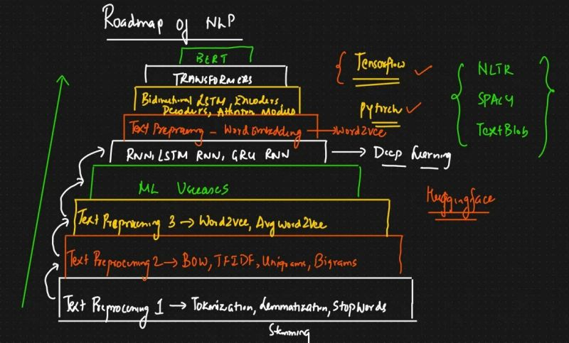

Tokenization:
Tokenization is a foundational process in natural language processing(NLP) that involves breaking down a stream of text into smaller units called tokens.

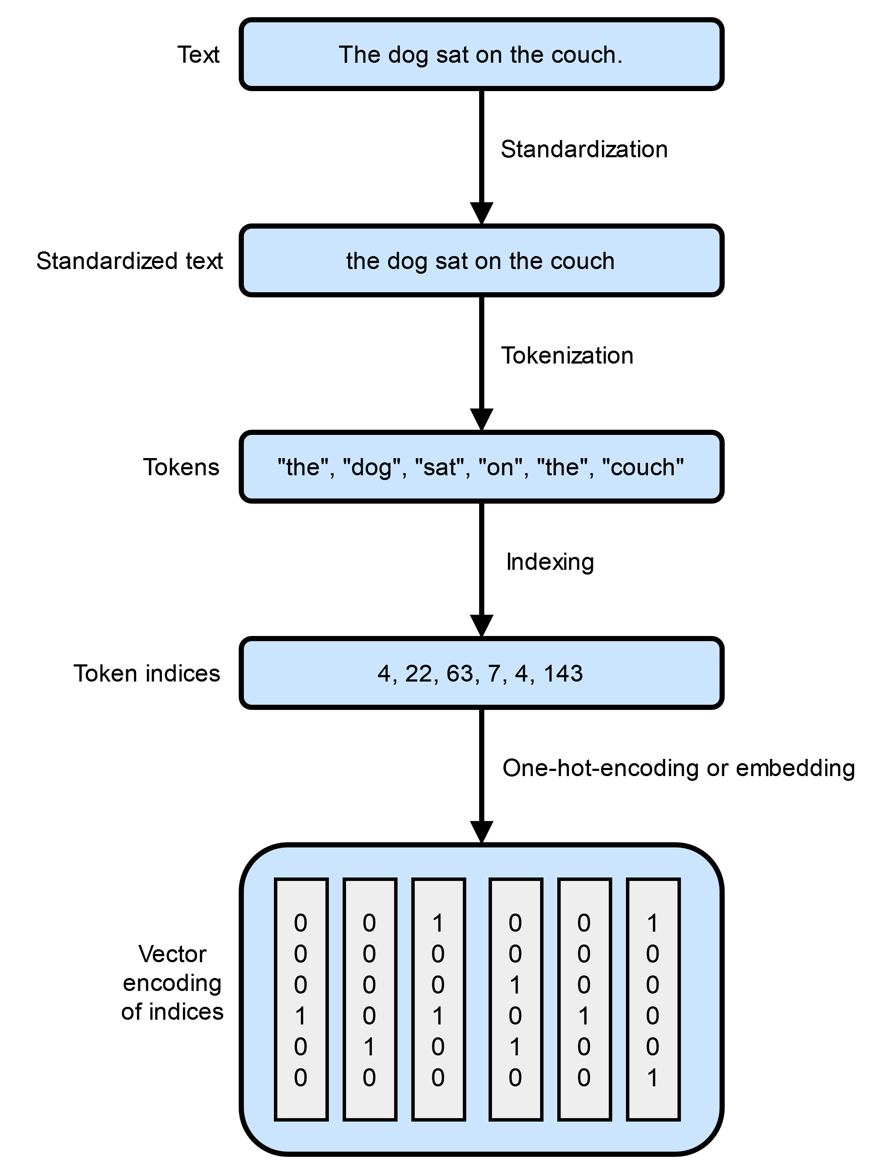

Some Topics:
1. Corpus:
A corpus is a large, structured collection of written or spoken texts used for linguistic analysis. This is the raw material that the entire NLP process begins with.Tokenization is the very first step applied to a corpus to make it machine-readabke and analyzable.

2. Documents:
A corpus is typically made up of multiple individual documents. Tokenization is usually performed on a document-by-document basis, processing the text within each document into its constituent tokens.

3. Words(Tokens):
Words are the most common form of token produced by the tokenization process. A token can be a single word, a number, a punctuation mark, or a subword unit, depending on the specific rules of the tokenization algorithm used. The process transforms continuous text into a list of these discrete units.

4. Vocabulary:
The vocabulary (also called “lexicon” or “vocab”) is the complete set of unique tokens found within the entire corpus after tokenization is complete and any text normalization (like lowercasing or stemming) has occurred. The size and content of the vocabulary are crucial for subsequent NLP tasks, such as creating word embeddings or building a language model.

Stemming:
It is a fast, heuristic process of reducing words to their base or root frorm by cutting of affixes, primarily suffixes. The resulting stem may not always be a valid dictionary word but serves to group different inflected forms of a word (e.g., "running," "runs," "runner" all become "run") to improve efficiency in text analysis.

